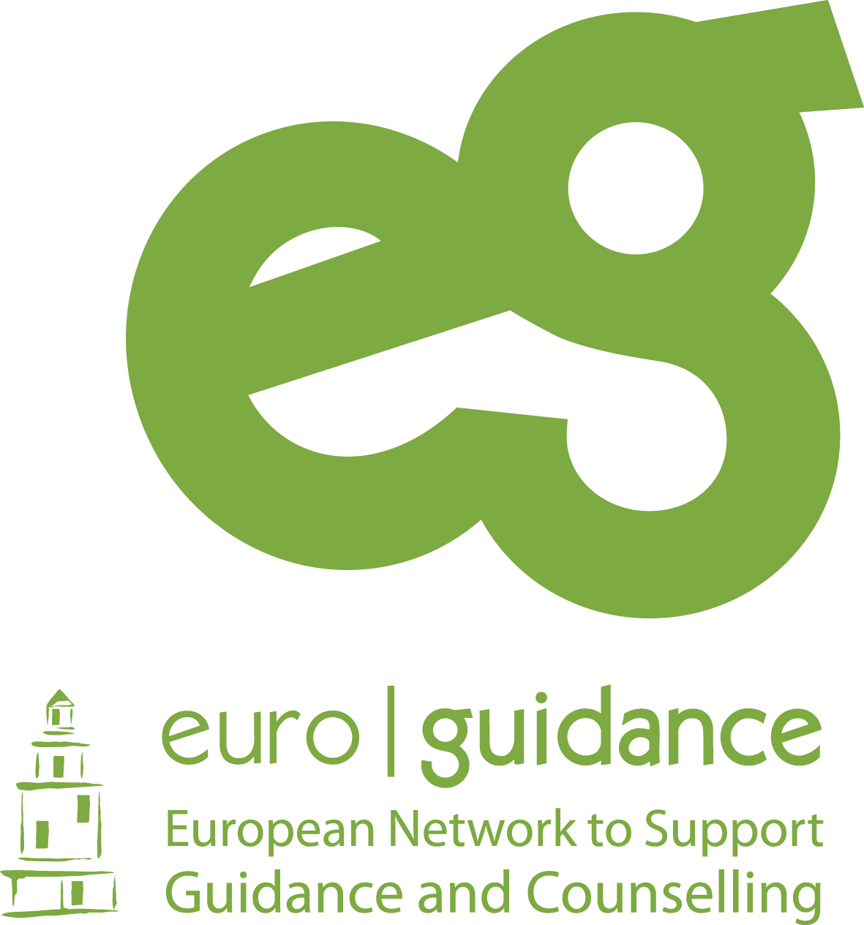
Preliminary Programme: “Guidance and the promotion of IVET”  Copenhagen 13 – 15 June 2022

Monday 13.06.2022 | Tuesday 14.06.2022 | Wednesday 15.06.2022
All day at the Hotel, DGI Byen  09.00 Welcome  09.15 Tour de table  Short presentation of the participants  10.15 - 10.45  Brief presentation of the Danish education system with focus on VET.  Birtha Theut, Euroguidance DK and Lars Møller Bentsen, Erasmus+ VET  10.45-11.00 Coffee break  11.00 – 12.00  Presentation of the Danish guidance system with special focus on the transition from compulsory school to VET  NN, Ministry of Children and Education | 09.00 Leave hotel  Metro/bus  9.30-11.30  Visit to VET College, NEXT – What is VET 10? Katrine Kruse | All day at the Hotel, DGI Byen  9.00 Leave hotel / walk  09.15 – 10.15 “Boss Ladies” – How to attract more women to VET?  10.15 – 10.30: Coffee Break  10.30-11.30  DK-Skills – How to promote the VET programmes to young persons?  11.30-12.30: Mutual discussions – presentations of best practice from all countries – exchange of experiences.
12.00-13.00 Lunch | 12.00 – 12.30 Lunch at the FGU Centre | 12.30 – 13.00 Lunch
13.00 - 13.45  Presentation of a recent evaluation , by NN, DPU, Aarhus University  13.45-14.00 Pair discussions of the most important messages of the presentation  14.00-15.00  Presentation by The Danish Organisation for VET students.  The Corps of Role Models - objectives and results. Presentations by VET students of their activities in the Corps of Role Models.  15.00-15.15 Coffee Break  15.15-16.15  Discussions in groups of the day’s programme and exchange of experiences | 12.30-14.30 Visit to the FGU Centre of Copenhagen (Preparatory education and training Centre)  Walk – 15 minutes  14.45 -16.00 Visit to UU Copenhagen, The Youth Guidance Centre of Copenhagen Karina Meinicke  New initiatives with focus on VET  Transport  16.30  Return to Hotel. | 13.00 – 14.00  Evaluations and Goodbye  Reflections on the visits.
19.00 Welcome Dinner, offered by the host | 19.00 Dinner, offered by the host

